A182-Afr-Egy-Ushabti-New Kingdom-19th Dynasty, 1291 – 1278 BCE-Seti I

**Figs. 1-2.** Ushabti-New Kingdom-19th Dynasty, 1291 – 1278 BCE-Seti I

**Case No.: 2**

**Formal Label: Egyptian** Ushabti-New Kingdom-19th Dynasty, 1291 – 1278 BCE-Seti I

**Display Description:**

This New Kingdom Pharaonic Ushabti, possibly of Seti I, has a plain lappet wig, a plaited divine beard, bodily canonical proportions, beautiful sculpting of the face, and expert design of the text.

**Accession Number:**

**LC Classification:** DT62

**Date or Time Horizon:** New Kingdom-19th Dynasty, 1291 – 1278 BCE

**Geographical Area: Luxor, Egypt-Valley of the Kings, Seti I, Tomb KV17**

**Map, GPS Coordinates:** [25°44′23.3″N 32°36′06.8″E](https://tools.wmflabs.org/geohack/geohack.php?pagename=KV17&params=25_44_23.3_N_32_36_06.8_E_type:landmark_region:EG)

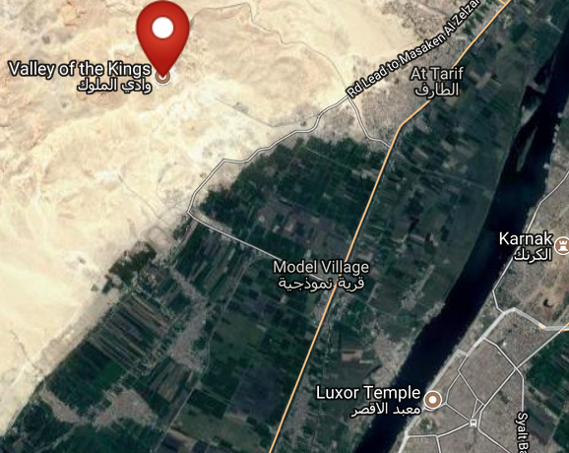 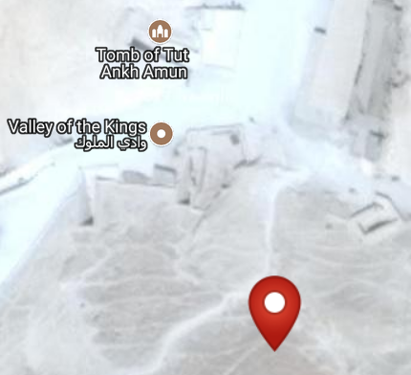

Figs. 3-4. Maps of KV17 from http://latitude.to/lat/25.73972/lng/32.60167

**Cultural Affiliation:** New Kingdom

**Medium:** steatite

**Dimensions: 237.66 mm; 9.357 in  
Weight: 1 lb, 8 3/4 oz; 692 gm**

**Provenance: unknown**

**Condition: original**

**Discussion:** When Seti I’s tomb, KV 17, was discovered by Giovanni Battista Belzoni in 1817, it contained more than 700 Ushabtis of wood, faience and glazed steatite. Since many of these ushabtis were covered with bitumen early visitors to the tomb would light the Ushabtis and use them as torches.

**References:**

Porter, Bertha, R. L. B. Moss and E. W. Burney. 1964. *Topographical bibliography of ancient Egyptian hieroglyphic texts, statues, reliefs and paintings.* 1, The Theban necropolis 2, Royal tombs and smaller cemeteries. 2. ed., rev. and augmented, 1 Part 2. Oxford: Griffith Institute.